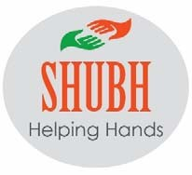
Shubh Helping Hands www.shubhhelpinghands.com

Registration Form

Date of Birth
Name

Cell Number

Address

Emergency Contact

Emergency Contact Phone

Yearly registration fee
$30 S60 $20 Cash Cheque
Membership @ Clubs: | Churchill Meadows: (Thursday)  Mississauga Valley Boulevard: (Monday)  River Grove: (Tuesday) ( $20)
Thank you, City of Mississauga, for providing us free rental spaces for our health and wellness activities for Senior’s and older group at Churchill Meadows Older Adult Centre, Mississauga Valley and River Grove Community Centre. | Please Note:  We will be using your Photos on SHH Social Media
T
………………………………………………………………………………………………………..…………….. ……………………………………………………………………………………………………………………………………….…….. Date Signature
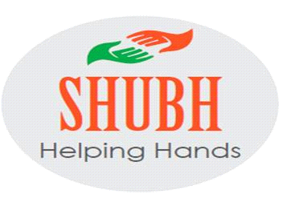
SHUBH HELPING HANDS.COM
VOLUNTEER / MEMBER WAIVER FORM
PLEASE READ CAREFULLY-GENERAL WAIVER FOR ALL VOLUNTEERS, PERMANENT, PART TIME OR CASUAL, FOR MEETINGS, TRIPS, EXCURSIONS, PICNICS, REFRESHMENTS / FOOD SERVED OR ANY ORGANIZED EVENT BY THE ABOVE MENTIONED SHUBH HELPING HANDS, MISSISSAUGA.
I, the undersigned_______________________________ duly sign and freely and voluntarily accept and assume all risks, dangers and hazards and the possibility of personal injury, sickness, death, violence, property damage or loss during or after effect of this any of the above mentioned or any other kind of events. By signing this waiver, I accept my responsibility to abide by the laws of this country in which the event takes place, to ensure that I have adequate medical coverage, protect personal possessions and obey all the rules.
LIABILITY WAIVE AND INDEMNIFICATION-In consideration of approval to participate in any of these events, myself and any personal representatives, heirs and assigns herby waive any rights relating to and release, and forever discharge Shubh Helping Hands Mississauga, its committee members, volunteers and staff from any and all liability, including without limitation actions, cause of actions negligence, claims and demands of damages, or loss or injury, resulting from or arising out of my participation in any events. I also agree to indemnify and save harmless Shubh Helping Hands Mississauga from any and all actions, causes of actions, demands, expenses, losses whatever which it may bear as results of my negligence or willful malfeasance participation in these events, by reason of damage to my and all property and any and all personal injuries including death of others or myself. The contents and the reason of signing of this waiver has been read to me and also explained to me verbally in Hindi.
Eating food provided to me is my own personal decision, Shubh helping hands should not be held liable or blamed for anything.

Signature of Member : ______________________ Signature of Witness : _______________
Date: _______________

